Cleaning for Computation of Utility

<Pre Data>
- U_w and others
- u_w>uii, uic : 0 case
- u_w>uipec: 3 cases
-1 Pareto Efficient case (coded 0 in computing the utility loss)
-2 other cases: when x_w=x_pec on 45 line and x_c buys more expensive goods
: For other cases, finding the x tilde which has minimum distance from collective choice is same to find a Pareto improvement of x_c which is closest to original collective choice. Howerver, when x_w on 45 line and x_c \in {x_cheaper<x_expensive}, they are not same, which means we have to find Pareto improvement set in manual way (Solution: Numerically searching Pareto improvement choice)
Case 1-2)
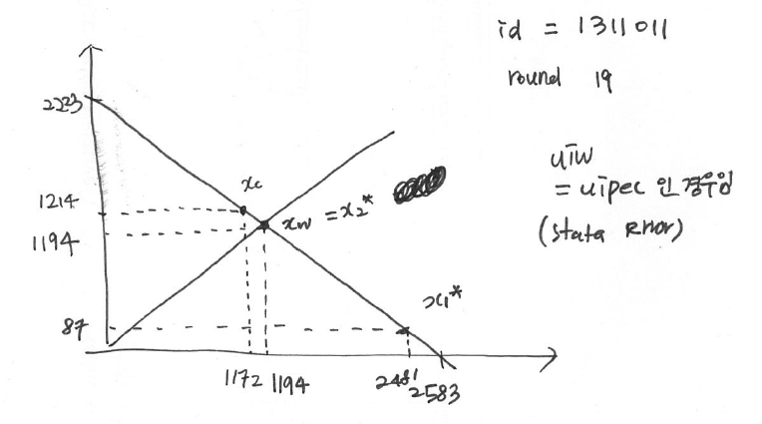

- U(x_pe)<u(x_c): x_pe is not a Pareto improvement of original collective choice
3562 cases out of 28296 | 3121 Pareto efficient (Solution: no need)
3562 cases out of 28296 | 441 cases are Pareto inefficient | 441 (100%) cases is in which subjects invested more on expensive goods making collective choice | 441 cases have individual alpha<0.5 (therefore, individuals are better off when choosing any extreme points even when it wastes some money rather than middle ones, which is partner’s optimal choice) (Solution: Numerically searching Pareto improvement choice)

<Post Data>
- U_w and others
- u_w>uii, uic : 0 case
- u_w>uipec: 3 cases
-2 Pareto Efficient case (coded 0 in computing the utility loss)
-the other case: when x_w=x_pec on 45 line and x_c buys more expensive goods
: For the other case, finding the x tilde which has minimum distance from collective choice is same to find a Pareto improvement of x_c which is closest to original collective choice. Howerver, when x_w on 45 line and x_c \in {x_cheaper<x_expensive}, they are not same, which means we have to find Pareto improvement set in manual way (Solution: Numerically searching Pareto improvement choice)

- U(x_pe)<u(x_c): x_pe is not a Pareto improvement of original collective choice
2984 cases out of 26640 | 2674 Pareto efficient (Solution: no need)
2984 cases out of 26640 | 310 cases are Pareto inefficient | 310(100%) cases is in which subjects invested more on expensive goods making collective choice | 310 cases have individual alpha<0.5 (therefore, individuals are better off when choosing any extreme points even when it wastes some money rather than middle ones, which is partner’s optimal choice) (Solution: Numerically searching Pareto improvement choice)

